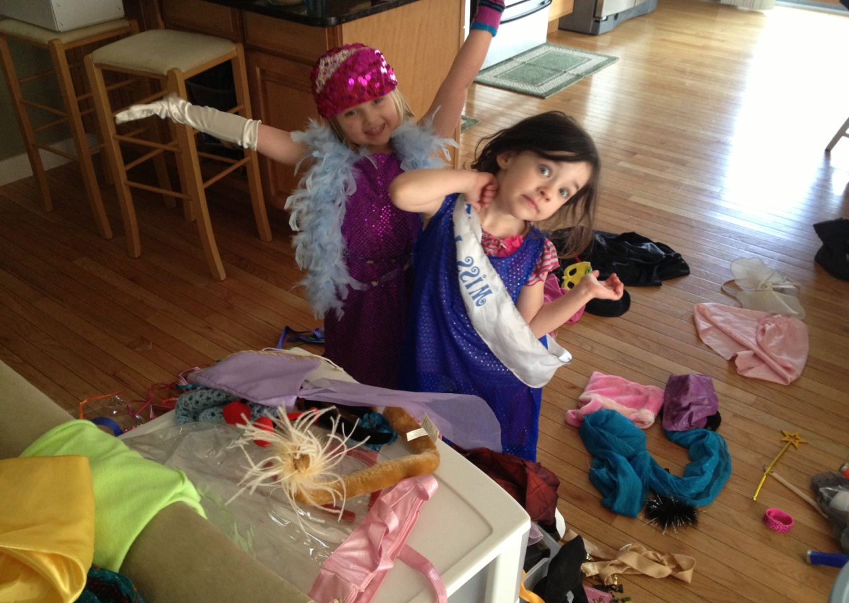
My Craaazy Cousins
My cousins are crazy, and they’re very cuckoo, They are both very crazy to both me and to you,
It’s crazy I tell you, they run here they run there, They’re especially crazy about what they wear, My cousins are crazy, and now that you know, I think it is time now that I should go.
By Keelin

