Name ______________________________________ Date _____________
Social Studies Unit 1 - Climate

Word Meaning Picture
The condition of the air at a certain time and place
Wind
Temperature
Precipitation
weather

The weather of a place averaged over a long period of time.
AVERAGE
Temperature
Amount of Precipitaton
climate

Amount of rain or snow that falls

Rain, Snow, Sleet, Hail, Freezing Rain
precipitation

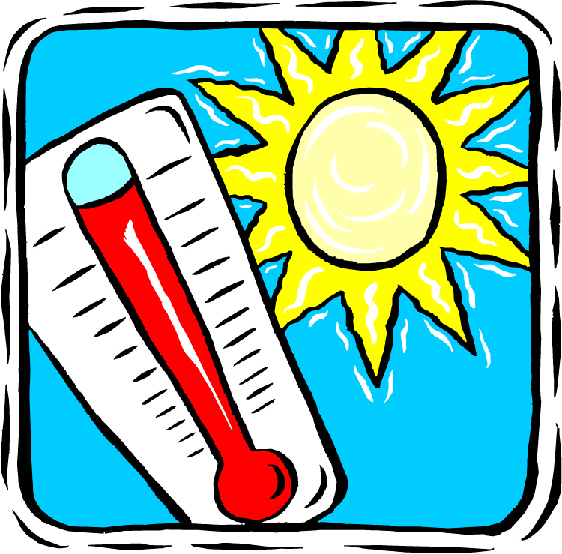
How warm or cold a place is

temperature


The amount of moisture in the air

humidity

Word Meaning Picture

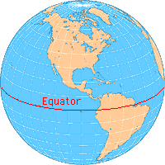
equator
An imaginary line that circles Earth halfway between the North and South poles

Tells how high a place is above sea level
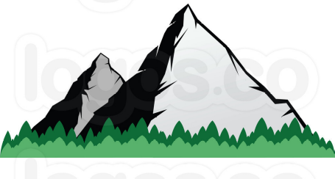
elevation

Word Meaning Picture
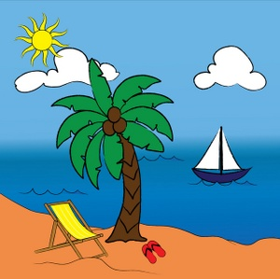
Very warm ALL YEAR round
Near the equator

tropical
climate

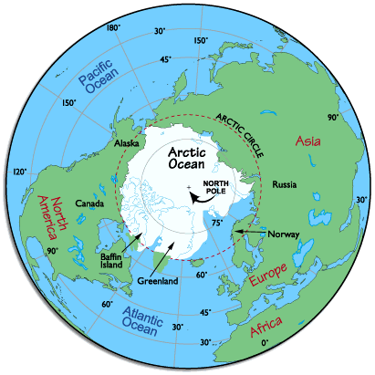
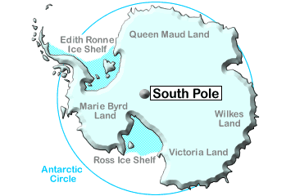
Coldest climate
*very small part of Alaska is a polar climate

polar
climate

- Warm periods are short
- Parts of covered in snow year round
Alaska
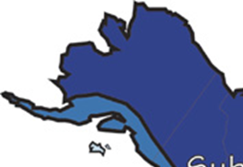
subarctic
climate

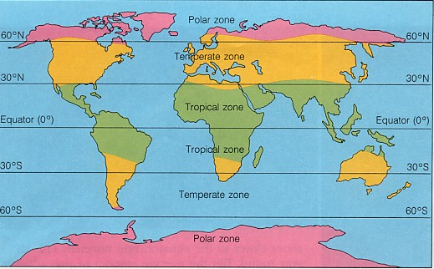
Moderate in temperature: neither too hot nor too cold

temperate
climate

