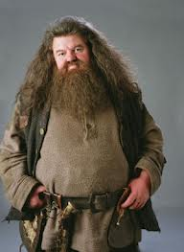
Harry Potter and the Sorcerer’s Stone
Written by: J.K. Rowling
“Harry looked up at the giant. He meant to say thank you, but the words got lost on the way to his mouth and what he said instead was “Who are you?”
The giant chuckled.
“True, I haven’t introduced myself. Rubeus Hagrid Keeper of Keys and Grounds of Hogwarts.”
Who is Rubeus Hagrid? Who or what is Hogwarts? Read the book to find out.
Harry Potter and the Sorcerer’s Stone is a great way to start off the Harry Potter series and a summer filled with fun, exiting books.

